**JABO JUSTIN INDIVIDUAL PROJECT FOR WEEK 4**

***QUESTION:***

**Individual Project:**

Using the database created in **Part 2** of the **Week 4 Practice Problem (Lab 4)**, answer these questions with SQL. Your submission must include screenshots of your output table and your queries. Always sort the aggregate columns in descending order and note that SQL Sandbox uses **SQLite database.**

1. What are the total sums of freights of ship cities that have 30 or more customers?
2. Generate a table of employees and the number of customers they handle
3. How many orders were made each year?
4. What quantity of the product ‘**Chang**’ was shipped in 2014?
5. What are the revenues per supplier in 2013 before and after discount applied? Show both values in a single table.

***ANSWER:***

***Question 1.***

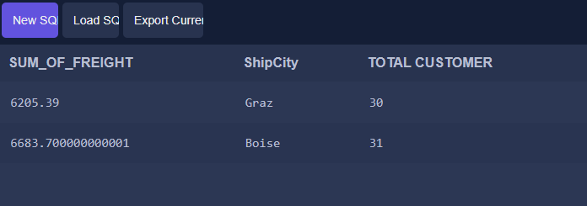

SELECT SUM(Freight) AS SUM_OF_FREIGHT, ShipCity,  
COUNT(CustomerId) AS 'TOTAL CUSTOMER' FROM 'Order' AS O JOIN Customer AS C ON C.Id = O.CustomerId  
GROUP BY CustomerId  HAVING count(CustomerId) >= 30;

***Question 2.***

SELECT EmployeeId, COUNT(DISTINCT(CustomerId)) AS No_Customers FROM 'Order'  
GROUP BY EmployeeId;

***Question 3.***

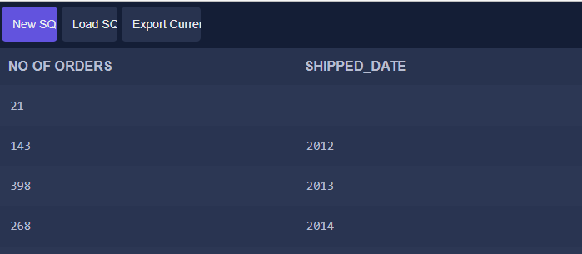

SELECT COUNT(Id) AS 'NO OF ORDERS',  
STRFTIME('%Y', ShippedDate) AS 'SHIPPED_DATE'  
FROM 'Order'  
GROUP BY  
STRFTIME('%Y', ShippedDate);

***Question 4.***

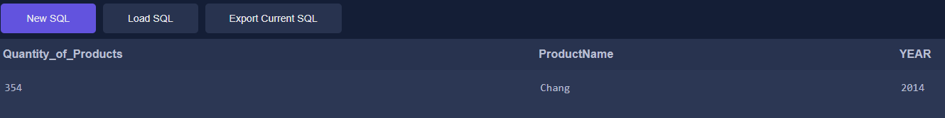

SELECT SUM(OrderDetail.Quantity) AS Quantity_of_Products, Product.ProductName, 'Order'.ShippedDate  
FROM OrderDetail  
INNER JOIN Product ON OrderDetail.ProductId = Product.Id  
INNER JOIN 'Order' ON 'Order'.Id=OrderDetail.OrderId  
WHERE ProductName='Chang' AND STRFTIME('%Y', ShippedDate) = '2014';

***Question 5.***

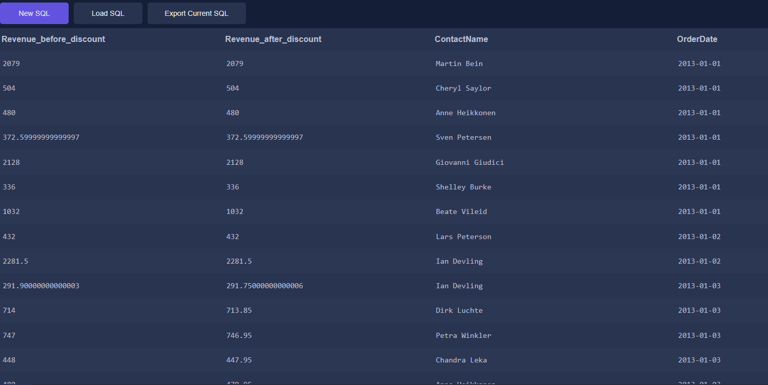

SELECT (OrderDetail.UnitPrice * OrderDetail.Quantity) As Revenue_before_discount,

(OrderDetail.UnitPrice * OrderDetail.Quantity)-(OrderDetail.Discount) AS Revenue_after_discount,

Supplier.ContactName, 'Order'.OrderDate

FROM OrderDetail

INNER JOIN 'Order' ON OrderDetail.OrderId='Order'.Id

INNER JOIN Product ON OrderDetail.ProductId = Product.Id

INNER JOIN Supplier ON Product.SupplierId= Supplier.Id

WHERE STRFTIME('%Y', OrderDate)='2013';